# This article is about the OT-One.

## **It's no-longer sold or actively supported by Opentrons, but we've kept this article here to help existing users. Please** [**see our OT-2 Support articles**](https://support.opentrons.com/) **for the most up to date information!**

Once you've [downloaded a protocol](http://support.opentrons.com/getting-started/how-to-run-protocols/downloading-protocols), or [written your own protocol](http://docs.opentrons.com/), you need to upload it to the OT App. Click the "Click to Upload" button inside your OT App, and find the downloaded protocol on your computer to upload. Protocols are written in the programming language, Python, hence written and saved protocols should be saved with the .py file extension. (For example, my_protocol_file.py)

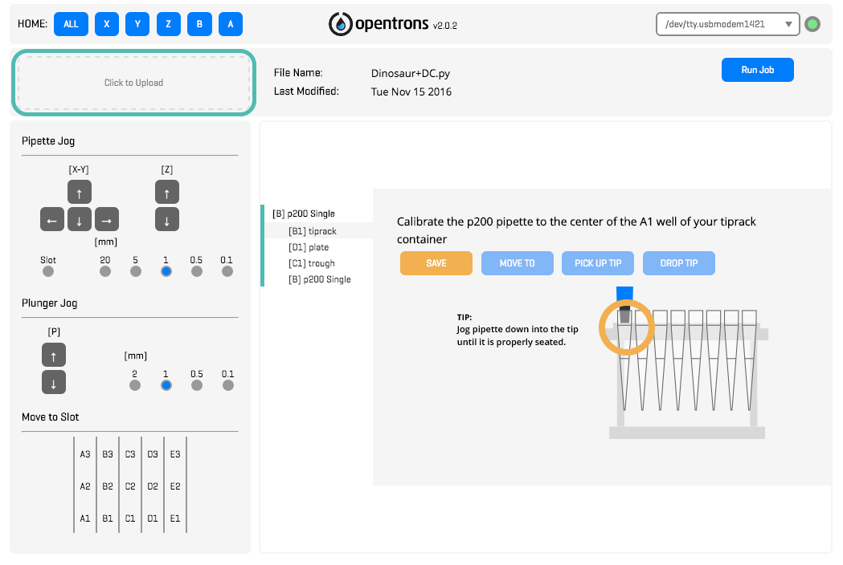

Once your protocol is loaded, a list of all of the containers needed for your protocol will pop up. Each of these needs to be calibrated before your protocol can run. Click to learn how to calibrate the [containers](http://support.opentrons.com/getting-started/how-to-calibrate-containers-and-pipettes/calibrating-the-deck) and the [pipettes](http://support.opentrons.com/getting-started/how-to-calibrate-containers-and-pipettes/calibrating-the-pipettes).

After you've calibrated your containers and pipettes, you can run your first protocol! Press the "Run Job" button in your OT App, sit back, and enjoy your new hands-free workflow! Once the protocol starts, a pop up will show you a list of commands as they occur. On this screen, you can also pause, resume or cancel your protocol.

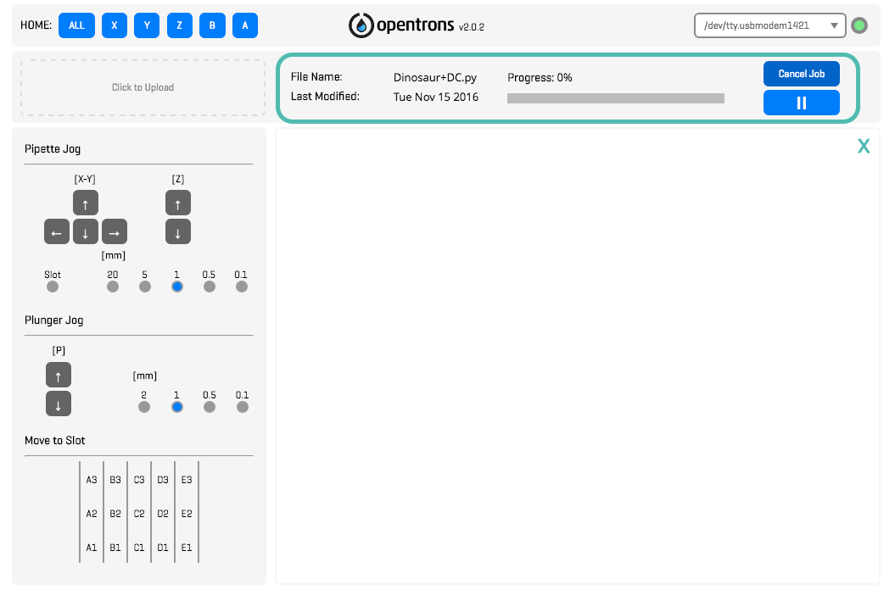

When you're ready to move on to a different protocol, remember to visit our [protocol library](https://protocols.opentrons.com/) for inspiration. If you'd like to dive in a little deeper, you should check out the [Opentrons API](http://docs.opentrons.com/) for some tips on creating your own custom protocols and python files. Also, be sure to take a look at our available [add-on modules](https://shop.opentrons.com/collections/labware) as you automate more of your workflows!

We're here to help at every step along the way, so please contact us with any questions.

# Welcome to the Opentrons community!